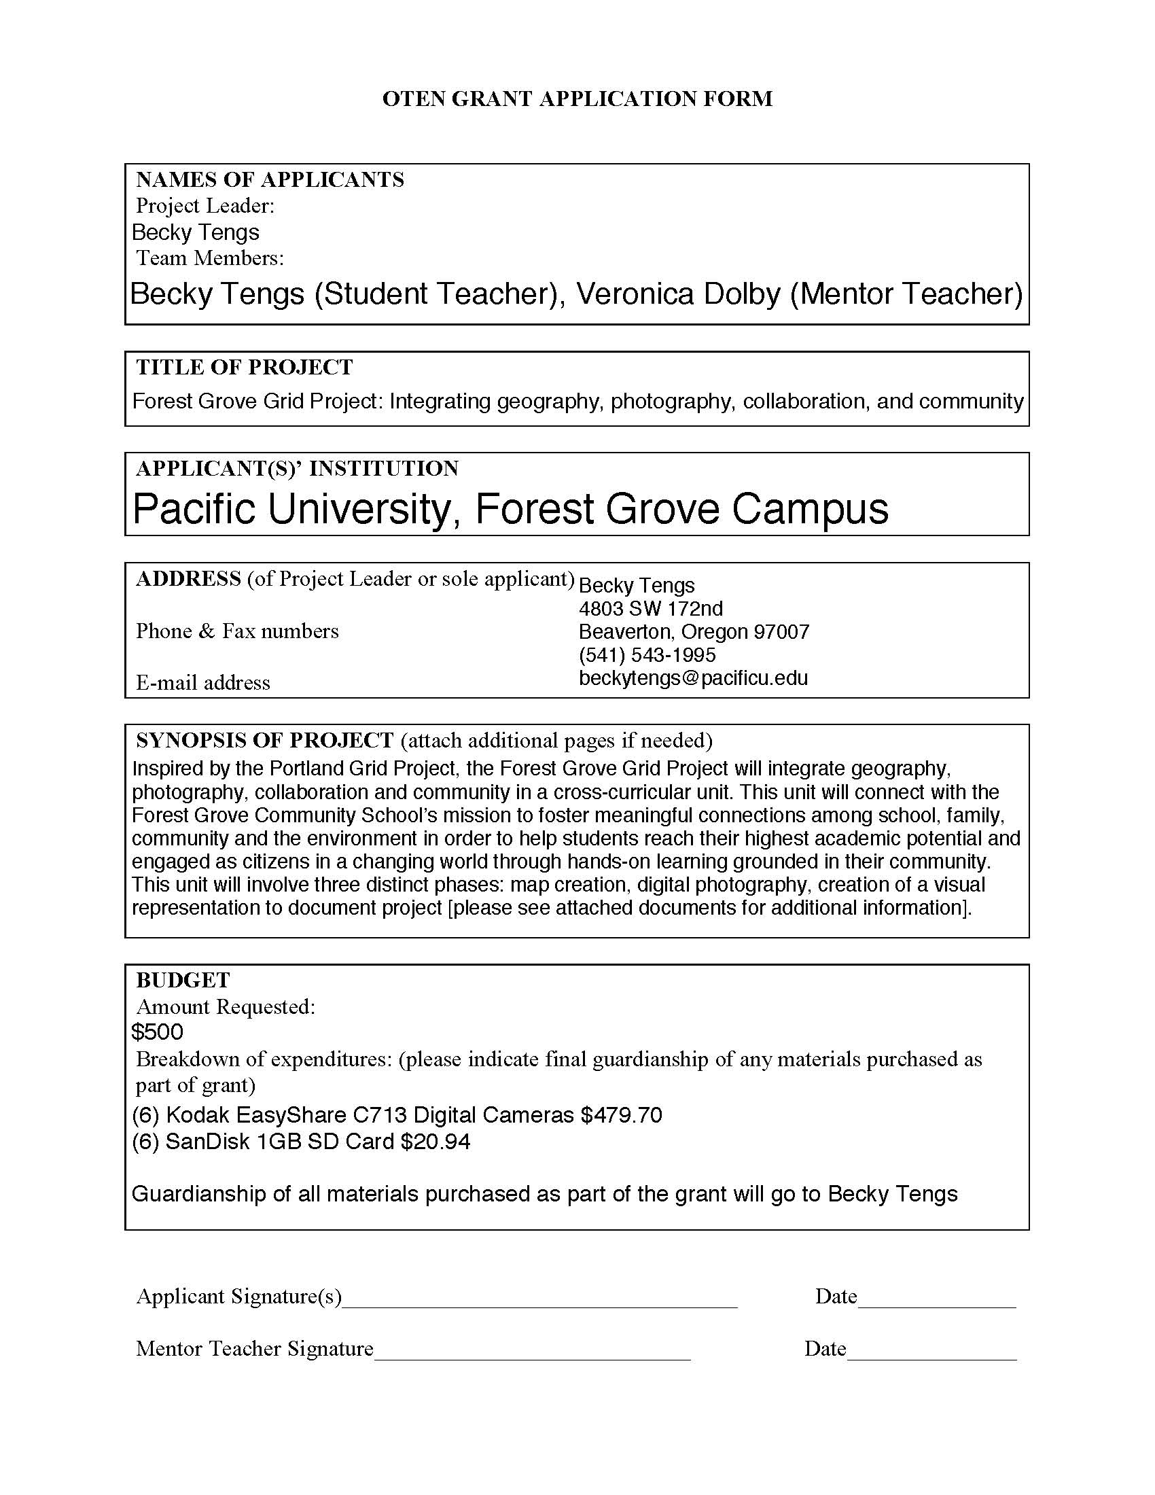
November 30th, 2008

Dr. Mark Bailey
OTEN Coordinator
Pacific University
College of Education
Berglund Hall
Forest Grove, Oregon 97116

RE: Oregon Technology Mini-Grant Proposal

Dear Dr. Bailey:

On behalf of my work sample at the Forest Grove Community School I am pleased to submit this proposal, The Forest Grove Grid Project: Integrating geography, photography, collaboration, and community, to the Oregon Technology in Education Network. Inspired by the Portland Grid Project this proposal will connect with the Forest Grove Community School’s mission to foster meaningful connections among school, family, community and the environment in order to help students reach their highest academic potential and engage as citizens in a changing world through hands-on learning grounded in their community. This unit will involve three distinct phases: map creation, digital photography, and the creation of a visual representation to document the project.

By the end of this unit, students will be able to apply their digital photography and geography skills by creating a final visual representation of a selected area in Forest Grove, Oregon. This will facilitate a stronger connection to community and promote student collaboration using a digital medium.

I am excited about the prospect of working with the Oregon Technology in Education Network to promote the National Educational Technology Standards within the context of an elementary school classroom. I am committed to providing hands-on, project-based learning in order to develop stronger ties to the community and create digitally responsible students.

Thank you for your time,

Becky Tengs
4803 SW 172nd
Beaverton, OR 97007
(541) 543-1995
beckytengs@pacificu.edu

Forest Grove Grid Project:
Integrating geography, photography, collaboration and community

Demographic Information:

Student Teacher:
Becky Tengs
4803 SW 172nd
Beaverton, OR 97007

541-543-1995
beckytengs@pacificu.edu

Mentor Teacher:
Veronica Dolby
Forest Grove Community School
1914 Pacific Avenue
Forest Grove, Oregon 97116

Grade Level: Blended 4th/5th/6th grade classroom

Primary Content Area: Geography

Instructional Design
Inspired by the Portland Grid Project, the Forest Grove Grid Project will integrate geography, photography, collaboration and community in a cross-curricular unit. This unit will connect with the Forest Grove Community School’s mission to foster meaningful connections among school, family, community and the environment in order to help students reach their highest academic potential and engage as citizens in a changing world through hands-on learning grounded in their community. This unit will involve three distinct phases: map creation, digital photography, and creation of a visual representation to document project.
The involved Level 2 class at the Forest Grove Community School has approximately 24 fourth, fifth, and six grade students. The (6) digital cameras will allow for small group collaboration ranging between three and four students each. Each student will have ample opportunities to take digital photographs, document their photos, and reflect on the process. In the first phase, small groups of students will select an area of Forest Grove they would like to document. Students will rely on prior knowledge of Forest Grove, Oregon due to personal experiences as well as group experiences during Out-And-About field trips. Each group must submit a written proposal regarding their area. This proposal will include a rationale to their selection, address, and desired outcome of document. Due to logistical and safety issues, the selected areas may not occupy more than a one block by one block radius (approximately); additionally, the locations will need to be reviewed by myself and my mentor teacher, Veronica Dolby, before the proposal is accepted.
After proposals are accepted, students will participate in an inquiry activity regarding maps. This will involve introductory lessons regarding: what a map is, what a map measures, measurement techniques and tools, units of measure, history of measurement units, the agenda of specific maps, and their potential inaccuracies. Students will be exposed to a variety of world maps, state maps, as well as local maps. Upon visiting each selected area, students will take this knowledge and apply it to creating maps of their specific proposed areas. Although, each small group will independently collaborate in order to determine their area in Forest Grove to study, each individual student will create a map of the specific areas. These maps will be compiled in a “Forest Grove Grid Project” journal including their specific maps as well as journal reflections regarding the process.
The second phase of this unit will include the digital photography. Students will first participate in a WebQuest inquiry activity involving the Portland Grid Project and the landscape-as-mirror genre made famous by such photographers as: Timothy O’Sullivan, Walker Evans, Diane Cook, Ed Ruscha, Robert Adams, August Sander, Eugene Atget, and Edouard Baldus. Currently, the Portland Grid Project is only on exhibit in the Portland International Airport. However, I have contacted the Portland Grid Project organizers requesting supplementary materials regarding this exhibit in order to facilitate inspiration within students to document their community. If I am successful in obtaining these materials, they will be supplementary to the WebQuest.
After being exposed to the history behind the Portland Grid Project and the landscape-as-mirror genre, students will then gain experience using the digital medium. Due to the economic conditions of many students, they may not have the resources for digital cameras in the home. Therefore, this unit will structure specific time to learn how to take photographs, use the digital cameras, as well as uploading and editing photos. The Regional Arts and Culture Council (Portland Grid Project exhibit sponsor) may be able to provide a resident artist workshop focusing on students and photography – with the intention of encouraging students to overcome inhibitions regarding being in front of and behind the camera lens. If this does not occur, a digital camera scavenger hunt will take place in order for students to become familiar with this technology. Once students gain experience using the digital photography medium, we will take the cameras into the specific areas proposed by the small student groups. Much like the map creation activity, although each small group will independently collaborate in order to determine their area to study, each individual student will be responsible for taking photos of the areas within their small groups. The small group that selected the area will be responsible for compiling, editing, and selecting the photos to be representative of the area – this will occur in the final finished product stage.
After all students have had ample opportunities to take photographs of their group selected area (as well as the areas of the other groups), these photographs will be compiled based on location. The group that selected the location will obtain these photos from their peers, edit, and select approximately ten photographs to be representative of the area. Once each group completes this process, the class will collaborate to determine the final product. Students will create visual representations of these areas using geographical map skills as well as digital photography skills. These visual representations will be compiled, reviewed, and edited by students to create a finished product. This finished product will be determined by the class -- suggestions include: posters, brochures, photo books, or a website.
This unit will take place between April 6th, 2009 and June 12th, 2009. If funded, Student Teacher, Becky Tengs will present the progress of this unit at the Spring OTEN conference.

Learning Goals
By the end of this unit, students will be able to apply their digital photography and geography skills by creating a final visual representation of a selected area in Forest Grove, Oregon. This will facilitate a stronger connection to community and promote student collaboration using a digital medium.

Oregon Benchmarks:
- Fifth Grade ODE Art Standards:
  - AR.05.CP.01 → use experiences, imagination, observations, essential elements and organizational principles to achieve a desired effect when creating, presenting and/or performing works of art
  - AR.05.CP.04 → critique one’s own work using self-select criteria that reveal knowledge of the arts, orally and in writing
  - AR.05.HC.03 → describe how works of art from various historical periods reflect the artist’s environment, society and culture
- Fifth Grade ODE Math Standards
  - MA.05.ME.02 → understand that measurements are approximations and understand how differences in units and tools affect precision
  - MA.05.ME.04 → determine measurements of length and perimeter to the nearest tenth centimeter and nearest tenth meter
  - MA.05.GM.07 → Make and use coordinate systems to specify locations and describe paths
  - MA.05.GM.08 → Find the distance between points along the horizontal and vertical lines of a coordinate system
- Fifth Grade ODE Social Science Standards:
  - SS.05.GE.01 → define basic geography vocabulary such as concepts of location, direction, distance, scale, movement, and region using appropriate words and diagrams
  - SS.05.GE.01.01 → know and use basic map elements to answer geographic questions or display geography information
  - SS.05.GE.02 Examine and understand how to prepare maps, charts, and other visual representations to locate places and interpret geographical information
  - SS.05.GE.02.01 Use maps and charts to interpret geographical information
  - SS.05.GE.02.02 Use other visual representations to locate, identify, and distinguish physical and human features of places and regions
  - SS.05.SA.02 → gather, use, and document information from multiple sources

International Society for Technology in Education –
National Educational Technology Standards:
- Creativity and Innovation:
  - Apply existing knowledge to generate new ideas, products, or processes
  - Students create original works as a means of personal or group expression
- Communication and Collaboration:
  - Interact, collaborate, an publish with peers employing a variety of digital environments
  - Contribute to project teams to produce original works
- Critical Thinking, Problem Solving, and Decision Making:
  - Plan and manage activities to complete a project
  - Collect and analyze data
  - Use multiple processes and diverse perspectives to explore alternative solutions
- Digital Citizenship:
  - Exhibit a positive attitude toward using technology that supports collaboration, learning, and productivity
- Technology Operations and Concepts:
  - Understand the use technology systems
  - Select and use applications effectively and productively
  - Troubleshoot systems and applications

Need for Technology
The Forest Grove Community School is a public charter school operated with funds from the Forest Grove School District. The charter school is only in its second year of operation, and does not have the same resources available to them as traditional public schools within the district. Currently the Forest Grove Community School does not have the technology resources available to meet the needs of this unit. There are currently (3) Apple computers located within the classroom to facilitate photo editing. However, no digital cameras are available. The majority of students at the Forest Grove Community School do not have digital cameras in the home. For many, this may be their first experience with this medium.
The underlying theme throughout this unit is student collaboration in order to facilitate learning. The use of digital cameras during the course of this unit will facilitate a strong visual bond between students and the Forest Grove Community. This unit will inspire students to see the beauty in the ordinary environment that surrounds their daily lives. Through the camera lens, students will be able to view their community differently. The use of digital cameras in this unit will allow students to construct a new notion of how to create visual representations of their daily lives. Additionally, this project will allow students to collaborate in order to create original digital photography and the means in which to display these photographs. The final products will not only be an extension of personal and class expression, it will also be a product of community expression. Without the use of digital cameras, the visual connection to the beauty of the community and development of community pride will not be possible.

Assessment and Evaluation
By the end of this unit, students will be able to apply their digital photography and geography skills by creating a final visual representation of a selected area in Forest Grove, Oregon. The assessment and evaluation for this unit will involve several elements: participation, self- evaluation, peer evaluation, teacher feedback, and final product. After each phase of the unit, students will complete a journal free write regarding their experiences. Students will compile these journal responses into a journal entitled “Forest Grove Grid Project” and will not only include their personal reflections, but the final versions of their area maps, self-evaluation and peer-evaluation forms.
Upon completing the geography phase of this unit, students will complete a self-evaluation regarding their participation in this phase of the unit. Additionally, as students will predominantly be working within groups of 3 or 4, group members will complete a peer evaluation regarding their fellow group members. This collection of materials will be evaluated collaboratively between the student teacher and mentor teacher. Students will be assessed based on their level of participation in completing all elements of the phase. Feedback regarding this participation will be provided to students based on their submissions. As a class, students will collaborate in order to create a final visual presentation with all of the data collected during the geography and photography phases. Each group will be responsible for producing a final version representing the geography and photography of their selected area. These maps must contain the map-making elements discussed during the first phase of this unit (appropriate measurement units, scale, key, important geographical features included).
The assessment materials will be submitted at the end of the unit. However, my mentor teacher and I will continually observe students in order to determine the quality of their participation in the project, ability to collaborate within their small groups, as well as their ability to collaborate with the group as a whole.

Detailed Budget

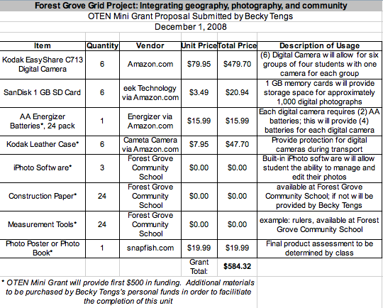

Item Details
